Operators
Lesson link
https://www.w3schools.com/java/java_operators.asp
Operators allow you to manipulate, compare, and perform calculations using primitive data types, followed closely by control flow statements. Understanding these concepts allows you to manipulate data and control the order in which your code executes.
Operators | Explaination
Arithmetic Operators  These perform standard mathematical calculations. | - + (Addition): Adds values together (e.g., 5 + 3 equals 8).  - - (Subtraction): Subtracts one value from another (e.g., 10 - 4 equals 6).  - * (Multiplication): Multiplies values (e.g., 3 * 4 equals 12).  - / (Division): Divides values (e.g., 15 / 3 equals 5).  - % (Modulus): Returns the remainder of a division (e.g., 7 % 3 equals 1, because 3 goes into 7 twice with 1 left over).
Unary Operators  Unary operators are the types that need only one operand to perform any operation like increment, decrement, negation, etc. It consists of various arithmetic, logical and other operators that operate on a single operand. Let’s look at the various unary operators in detail and see how they operate. | 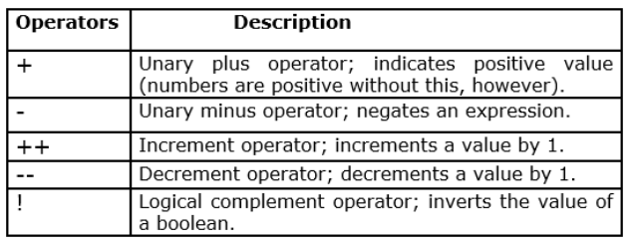
Assignment Operators  These store values inside variables | 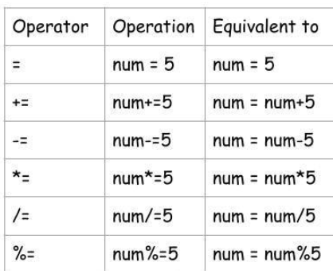
Ternary Operator  Conditional operator that takes three operands. It’s a one-liner replacement for the if-then-else statement | variable = Expression1 ? Expression2 : Expression3
Comparison / Relational Operators  They return a boolean result after the comparison and are extensively used in looping statements as well as conditional if-else statements and so on. | 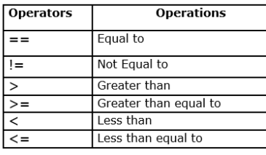  These compare two values and always result in a boolean (true or false).  - == (Equal to): Checks if two values are the same (e.g., 5 == 5 is true).  - != (Not equal to): Checks if two values are different (e.g., 5 != 3 is true).  - > and < (Greater / Less than): Compares sizes (e.g., 10 > 20 is false).  - >= and <= (Greater / Less than or equal to): Includes the boundary number (e.g., 5 >= 5 is true).
Logical Operators  These combine multiple comparison conditions together to make complex decisions.  One thing to keep in mind is, while using AND operator, the second condition is not evaluated if the first one is false. Whereas while using OR operator, the second condition is not evaluated if the first one is true | 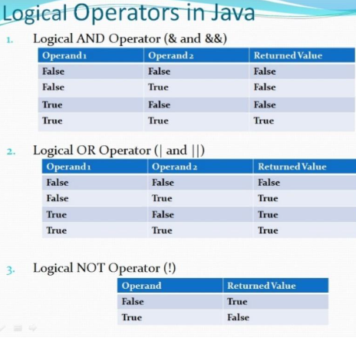

Operator precedence
Operator precedence determines the order in which different operators are evaluated in a single expression. Think of it as the programming version of PEMDAS (Parentheses, Exponents, Multiplication, Division, Addition, Subtraction) from math class.
Without precedence rules, a computer wouldn’t know how to solve a mixed expression like 5 + 3 * 2.
The Core Rules of Precedence
When an expression contains multiple operators, Java evaluates them from highest precedence to lowest precedence.
Here is a simplified table of common Java operators, ranked from highest priority to lowest:

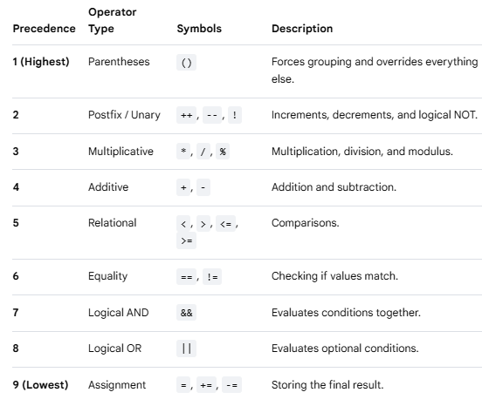

Associativity
When two operators have the exact same precedence level, Java uses associativity to decide the direction of execution.
- Left-to-Right: Most operators (like +, -, *, /) execute from left to right.
- Right-to-Left: Assignment operators (like =) execute from right to left.

Arithmetic Mix  int result = 10 + 5 * 2; | - Step 1: Multiplication (*) has higher precedence than addition (+). Java calculates 5 * 2 first, which is 10.  - Step 2: The expression becomes 10 + 10.  - Step 3: Java adds them together to get 20
Using Parentheses to Override  int result = (10 + 5) * 2; | - Step 1: Parentheses () have the highest absolute precedence. Java calculates 10 + 5 first, which is 15.  - Step 2: The expression becomes 15 * 2.  - Step 3: Java multiplies them to get 30.
Mixed Logic and Comparison  boolean check = 5 + 3 > 10 && 2 == 2; | - Step 1 (Arithmetic): 5 + 3 is evaluated first. The expression is now 8 > 10 && 2 == 2.  - Step 2 (Relational): 8 > 10 is evaluated. It is false. The expression is now false && 2 == 2.  - Step 3 (Equality): 2 == 2 is evaluated. It is true. The expression is now false && true.  - • Step 4 (Logical AND): false && true evaluates to false

